Cornell Society of Women Engineers

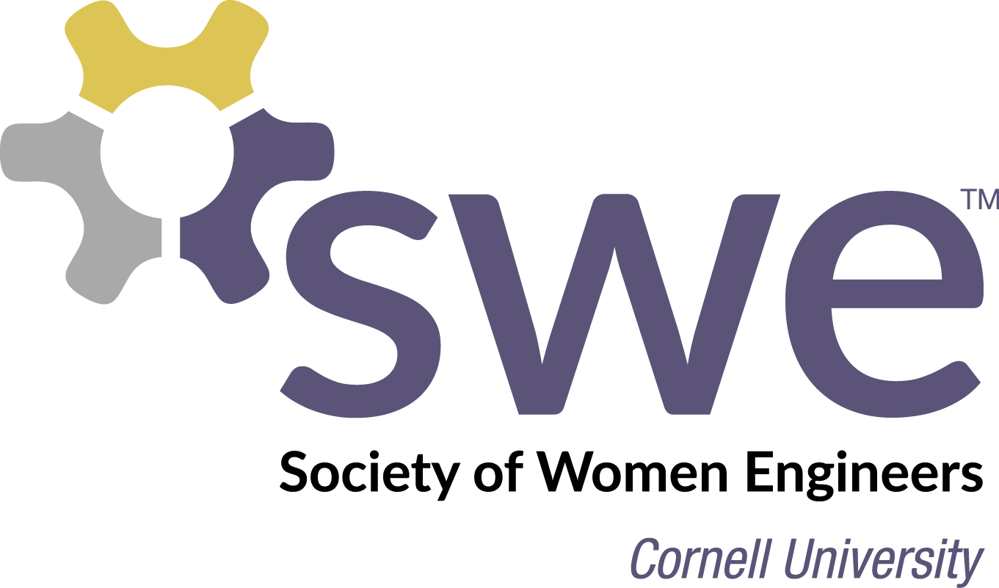 **CHAIR APPLICATION 2015-2016**

Name: ________________________________ Email: ______________

Campus Address: _______________________ Major: ______________

Phone Number: ___________ Year: ________ Student ID # __________

MANDATORY CHAIRS’ TRAINING: SATURDAY, SEPT. 12 @ 2pm

QUESTIONS:

1. Have you ever been involved in a SWE event in the past? If so, which ones?
2. Describe any other organizational or leadership experience you may have. Also, list other activities you are involved in this year.
3. What ideas do you have to improve the activities for which you are applying? Explain plans for new projects, designs, or organization.
4. Feel free to add any additional information or comments in the space below to describe your qualifications or ideas. If you have questions about any of the positions, contact the Directors or Presidents, Brittany (bw372) and Michelle (mhm249).

Enter as few/many positions as you like (Note: Corporate Relations Liaisons require a different application)

|  |  |
| --- | --- |
| **Rank** | **Chair Position**  Application Deadline is Friday, September 4th at 11:59 PM! Please title your application as follows: lastname_firstname_ChairApp  E-mail your application to presidents.cornellswe@gmail.com.  Thank You! |
| 1 |  |
| 2 |  |
| 3 |  |
| 4 |  |
| 5 |  |

***\* Note:*** *You can be both a chair and a liaison!* **OUTREACH**         Coral Keller (clk92) and Brielle Hohne (bch63)

*Note: For events which have most of their work takes place in only one semester, chairs may be away due to co-op, study abroad, etc. during the less critical semester. Chairs may also hold positions in two different events when one event is active in the fall semester and the other works during spring.*

**Outreach Coordinators (2):** Co-chairs with previous Outreach experience who will oversee committee meetings to coordinate and plan various Outreach events. Will act a liaison between directors and committees and will give guidance to chairs. Should have an interest in expanding leadership role within SWE Outreach. (1 to 2 semesters - 50 hours per semester)

* **Overnight:** Should have experience with planning an overnight event and will work closely Spring WIE Weekend committees.
* **Community Outreach:** Should have community outreach experience and will work closely with Girl Scout Day, Community Outreach Committees, and Campus Outreach Liaisons.

**Spring Women in Engineering Weekend Chairs (WIE Weekend) (4-5):** Co-chairs to work closely with Engineering Admissions and the Outreach Directors to coordinate a weekend for women who have been accepted into the College of Engineering. Will recruit hosts for overnight stay, invite speakers, arrange entertainment, and handle dining needs.  Will attend bi-weekly to weekly meetings led by Overnight Outreach Coordinators. (Mostly spring semester - total commitment of 60 hours, concentrated around the event weekend)

**Girl Scout Day Chairs (GS Day) (4-5):** Co-chairs will help coordinate a one-day event to help local girl scouts earn a badge. Will choose/coordinate badge activities, contact local Girl Scout troops, and coordinate volunteers. (Fall semester - 30 hours, Spring semester - 30 hours)

**Community Outreach Event Chairs (5):** Co-chairs responsible for coordinating a series of one-day events throughout the year. Will conduct outreach events both within SWE and with other engineering organizations by designing activities for all ages. Will coordinate volunteers and run activities at the Ithaca Sciencenter, the Jr. FIRST Lego League event, Engineering Day at the Mall, Chemical and Biological Engineering (CBE) Women's Graduate Outreach Group event, and Tau Beta Pi’s Engineering Fair. Will also explore opportunities to work with Encouraging Young Engineers and Scientists (EYES), Habitat for Humanity of Tompkins County Women Build, and Student Teacher Outreach Mentorship Program (STOMP). (Fall Semester - 15 hours, Spring Semester - 25 hours)

**Expanding Your Horizons (EYH) (4-5):** Co-chairs will create a proposal for a hands-on workshop for middle school girls. If the proposal is approved, chairs will finalize and coordinate activity for a one-day event. (Both semesters - Fall 10 hours, Spring 30 hours (if approved))

**Elementary/Middle School Outreach (4-5):** Co-chairs needed to design interesting, hands-on projects and coordinate volunteers to go to local elementary/middle schools during the fall study week to teach children about engineering and science. (Fall semester – 20 hours)

**High School Outreach (4-5):** Co-chairs plan monthly events for the high school mentorship program. Activities are held in the Fall and Spring semester designed to introduce high school women to the various science and engineering majors. Chairs will organize lab visits, panels and hands-on-activities. Will also collaborate with current high school students. (Both semesters – 30 hours in Fall, 30 hours in Spring)

**Winter Outreach Committee (4-5):** Chairs will help create and implement a new winter outreach program. This project is new and needs ambitious and interested chairs to help create a program to be implemented during winter break. (Fall Semester, 10-20 hours, flexible)

**Publicity Chair (1-2):** Chair(s) will be responsible for attending SWE Outreach events and taking photos, managing photos with Public Relations chairs and through the on-line SWE Flickr account, and assist with writing and coordinating event blurbs for General Body meetings. (Up to 15 hours per semester, both fall and spring semester)

**PUBLIC RELATIONS** **(PR)** Sanaya Shroff (sns62) and Sarah Parrotte (snp35)

**Alumni Relations (1)**: We are looking for one more chair to complete our three person Alumni Relations team. This member will be responsible for networking with alumni, planning and executing student-alumni events during occasions such as career fair, reunion, lunches, etc., updating a database of alumni, and creating a student-alumni networking and communications interface with a mentoring program. This has previously been an underdeveloped position and is ideal for individuals looking to make a huge impact on SWE. You will be working closely with the PR directors and the Office of Alumni Affairs. This position requires someone who is very passionate, comfortable interacting with alumni, a team player, and proactive.  (3-4 hrs/week)

**Faculty Relations (2)**: We are looking for two more chairs to complete our three person Faculty Relations team. These chairs will be responsible for planning one large-scale social event per semester with the engineering faculty and students to enhance student-faculty interaction. As the organizer of this event, your responsibilities include: finding and confirming a reservation for a venue, creating invitations and contacting faculty, publicizing the event to students through listserve emails, ground publicity, and announcements, creating a menu and ordering the dinner, as well as dealing with financial concerns and effectively communicating with the different directorships within SWE. This is ideal for someone who is comfortable and willing to interact with faculty, student leaders, and other staff members. We are looking for innovative, proactive, and team-oriented chairs. (3-4 hrs/week)

**Ground Publicity (3)**: We are looking for three very dependable and creative chairs to add to our five person Ground Publicity Team. These chairs will work together closely to promote SWE events effectively on campus by postering, quarter-carding, making invitations, etc. Each publicity chair will lead the publicity of specific events by coming up with creative ideas, but all chairs will still work as a team for door-to-door publicity of major events. If you like design and/or art this may be the position for you! (although of course no art or design experience/skill necessary). This position is extremely important to Public Relations, so we are looking for innovative students who will honor their commitment throughout the year.   (2-3 hrs/week)

**SWEmail/Newsletter (1-2)**: We are looking for one or two dependable, organized chairs who will help the directors send out weekly SWE mails by composing an online newsletter. This position will be responsible for keeping the SWE events calendar up to date and organizing SWEvents and SWEmails (weekly emails) into easy to read and informative newsletters.  In addition, these chairs will maintain are responsible for updating and decorating the bulletin board outside the SWE office, as well as regularly checking event details our online calendar with appropriate directors.  We are looking for proactive, organized applicants (2-3 hrs/week)

**Photography/Social Networking (1)**: We are looking for one chair who will aid the existing photography and social networking chairs in their respective duties. As a photography chair, you will be responsible for dividing up major SWE events (Professional Networking Dinner, Faculty Dinner, Outreach events, etc) with your co-chair to take pictures at. As a co-social networking chair, you will be responsible for helping maintain SWE’s Facebook page, Facebook group, Twitter account, and employing these various social medias to promote SWE and the organization’s events. If you are creative and/or are a good photographer, are technology savvy or enjoy working with social media, this position may be ideal for you. Having a digital camera is a plus but not required. (1-2 hrs/week)

**FUNDRAISING** Xinran Pan (xp33) and Manisha Basak (mmb299)

**Fundraising Chairs (5):**The fundraising directorship focuses on raising money to fund the SWE National Conference, as well as the many other events our section holds. We are seeking FIVE enthusiastic, creative, and hard-working chairs to help us brainstorm and organize fundraising events on campus. Chairs will also help sell SWE apparel during monthly Gbody meetings. In the weeks leading up to fundraiser events, the time commitment will be about 2 hours a week. Otherwise, we will hold monthly meetings. This position is very important to SWE as a whole, so we are looking for students who will honor this commitment.

**STUDENT SERVICES** Nini Shan (zs89) and Emily Cheng (erc77)

**Big/Little (4):** Do you like making connections with other students? If so, consider applying to be a Big/Little chair. You will be planning about **4** Big/Little events over the course of the school year (**2** in the fall, **2** in the spring) for all the Big and Little sisters (a family of **1-2** Bigs and **3-4** Littles). It’s not necessary to be a Big or a Little yourself. The type of event you plan is up to you, but we always recommend food! Past events have included movie nights, arts and crafts, etc.

**Socials (4):** Do you like to plan events? If so, consider applying to be a Social Chair! You will be deciding on social activities for SWE (Welcome picnic, coffee breaks and Breakfast for Dinner) and making sure the events come through. We plan to have **2** coffee breaks and **1** Breakfast for Dinner per semester. Time commitment is usually short for the events (**1-2** **hour shifts**) since planning and preparation occurs before the event.

**General Body (G-Body) (4):** Do you like meeting other members of SWE? If so, consider applying to be a G-Body Chair! You will be responsible for setting up tables, food, and any other equipment for the G-body meetings. Time commitment would about **2** hours (from **4~6PM**) at every monthly G-body meeting (for set up and clean up) and includes planning. Tasks would include deciding on a theme, social activity, and food options for each G-body. Please make sure you do not have class or other commitments during this time.

**CAREER DEVELOPMENT (CD)** Rachel Farrow (rmf236) and Vrinda Shukla (vs376)

**Career Development Chairs (2-3)**: Chairs will help plan and run one of SWE's largest events each semester, the Professional Networking Dinner. This dinner gives students and employers the opportunity to socialize over a meal catered by the Statler Hotel. Chairs will be responsible for contacting and interacting with company representatives, coordinating the logistics of the dinner, producing advertising materials, and selling tickets. Chairs may also help develop and plan other smaller professional development events throughout the year targeted to both SWE members and all engineering students. (Fall semester - 20 hours, Spring semester - 20 hours)

**CORPORATE RELATIONS (CR)** Vivian Liu (vwl9), Katharina Fung (kf259), Minghui Chen (mc762), and Shreya Jain (sj335)

**Inventory Management Chair (1):** Responsible for overseeing the inventory usage and purchasing supplies, products, and materials for Information sessions. Establish a spreadsheet and recording supplies usage at info sessions. Chair will need strong organizational skills to manage multiple supply orders and anticipate problems.

**CR Finance Chair (1):** Responsible for keep track of expenses and food ordering. Responsibilities includes managing invoices and accounting information from companies and info sessions and assist auditing all accounting works at the end of the semester, assisting E-shop food-ordering process. Strong organizational and finance management skills preferred.

**Publicity Chair (1):** Oversee the postering liaisons and assign them buildings to poster each week. Pick up information session posters from Sage Copy Center. Position requires good communication, punctuality, and organizational skills.

*\*You can serve both as a liaison and hold a chair position in a different directorship.*

*\*\*You must apply for Liaison on a* ***separate application****, which will be due earlier.*

**Liaison (50 positions):** Do you want to learn how to communicate professionally with company recruiters? Do you like networking opportunities and free food? Apply to be a SWE Corporate Relations Liaison! The role of a liaison is to help make company information sessions run smoothly. You kill two birds with one stone by getting your $20 member reimbursement while developing yourself professionally and practicing talking to recruiters. Each session generally requires about two hours total, and you need to complete a minimum of four info sessions in the fall and two in the spring for your reimbursement. That's only a maximum of eight hours of your time per semester. Be active and become a liaison!